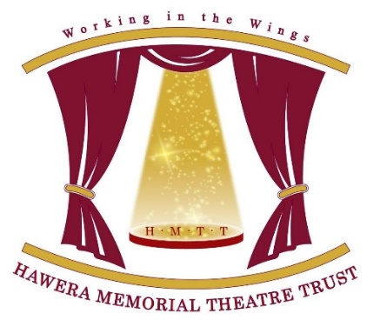
FRIENDS

Albion Street, Hawera

PO Box, 279 Hawera

haweratheatretrust@gmail.com
Hawera Memorial Theatre Friends
haweratheatrefrust.weebly.com
It’s easy to become a FRIEND or VOLUNTEER of the
Hawera Memorial Theatre.
Just follow the following simple steps.

Choose your area(s) of interest by ticking the appropriate box(es). (Tick as many as you like!)
1 | Donate annually to the Friends of the Theatre
2 | Become a volunteer (please tick as many as you like)
 | - Front of House duties
 | - Technical – Lighting
 | - Technical – Sound
 | - Green Room assistance, catering etc
 | - Stage crew
 | - Advertising & Promotion
3 | Join the Theatre Trust Singers
Once you have indicated your area(s) of interest, please write your name and contact details clearly on this form and send to the Secretary, wendyarm@xtra.co.nz and we will get back to you with further information.
Last Name | First Name
Email address
Phone number
If you prefer to post, please post to Secretary, HMTT, PO Box 279, HAWERA
You can also check out our website haweratheatretrust.weebly.com to find out a bit more about us.

